CENTRAL VIGILANCE COMMISSION (CVC), NEW DELHI
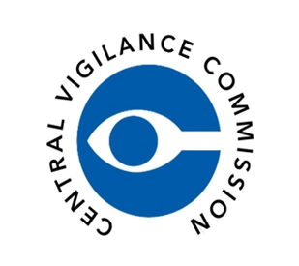

NATIONAL COUNCIL FOR TEACHER EDUCATION (NCTE), NEW DELHI

KALINGA UNIVERSITY, RAIPUR (C.G.)
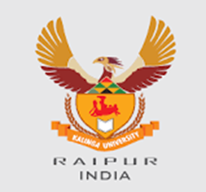
FACULTY OF EDUCATION
Theme: “सतर्कता: हमारी साझा जिम्मेदारी”
“Vigilance: Our Shared Responsibility – Education for Integrity and Transparency”

DAY 3 – Voice of Youth: Debate on Vigilance and Integrity
Date: 29 October 2025 | Time: 10:00 AM – 11:30 AM
Venue: WBFF 02 (Hybrid Mode)
Organized by: Faculty of Education & Faculty of Technology, Kalinga University, Raipur (C.G.)
Under the Guidance of: National Council for Teacher Education (NCTE) and Central Vigilance Commission (CVC India)
The Faculty of Education and Faculty of Technology jointly organized an inter-faculty Debate Competition titled “Voice of Youth – Debate on Vigilance and Integrity.” The event provided a vibrant platform for students to express their views on the topic “Integrity is the Foundation of a Corruption-Free India.” The session was inaugurated by Dr. V.C. Jha, Dean (In-Charge), Faculty of Technology, who inspired students to uphold moral values and critical thinking. Two teams participated — one representing Engineering students and the other representing B.Ed. trainees. The Engineering team focused on the role of technology in curbing corruption, while the B.Ed. team highlighted moral and educational values in promoting honesty and accountability.
After several engaging rounds, the team led by Sheetal (B.Ed. Department) was declared the winner for their reasoning, ethical depth, and clarity. Faculty members from both faculties served as judges, evaluating based on content, articulation, and relevance to the vigilance theme. Prof. Dr. Shraddha Verma, Dean, Faculty of Education, concluded the event with remarks appreciating teamwork and ethical insight.

Official Links:
Central Vigilance Commission (CVC): https://www.cvc.gov.in
National Council for Teacher Education (NCTE): https://www.ncte.gov.in
Kalinga University: https://www.kalingauniversity.ac.in
#VigilanceAwarenessWeek2025 #VoiceOfYouth #CVCIndia #NCTE #KalingaUniversity #EthicsInEducation #IntegrityMatters #Transparency #SatarkBharat #OurSharedResponsibility
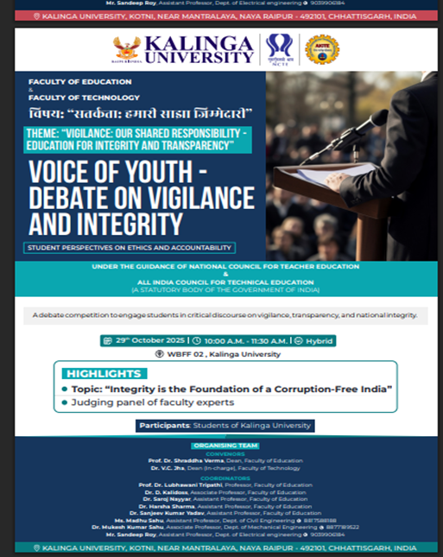 | 